1. Design a flowchart, Pseudocode, Algorithm for processing a customer order at a restaurant,

including handling special requests (Like add on).

**Algorithm**

1. Start
2. Display Welcome to Borgor King
3. Display Menu 1. Burger 2. Pizza
4. Display Please place an order 1 for Burger, 2 for Pizza
5. Read order
6. If order == 1
7. Then set order = Burger
8. Else if order == 2
9. Then set order = Pizza
10. End if
11. Display Would you like some add-ons? (y/n)
12. Read addons
13. If addons == y
14. Then display Would you like extra cheese? (y/n)
15. Read extraCheese
16. If extraCheese == y
17. Then add extra cheese to order
18. End if
19. Display Would you like extra meat? (y/n)
20. Read extraMeat
21. If extraMeat == y
22. Then add extra meat to order
23. End if
24. End if
25. Calculate totalCost of order including any add-ons
26. Display Your order is, order
27. Display Total cost is, totalCost
28. End

**Pseudocode**

START

DISPLAY Welcome to Borgor King

DISPLAY Menu: 1. Burger 2. Pizza

DISPLAY Please place an order 1 for Burger, 2 for Pizza

READ order

IF order == 1

Then set order = Burger

ELSE IF order == 2

Then set order = Pizza

END IF

DISPLAY Would you like some add-ons? (y/n)

READ addons

IF addons == y

Then display Would you like extra cheese? (y/n)

READ extraCheese

IF extraCheese == y

Then add extra cheese TO order

END IF

END IF

DISPLAY Would you like extra meat? (y/n)

READ extraMeat

IF extraMeat == y THEN

ADD extra meat TO order

END IF

END IF

CALCULATE totalCost OF order INCLUDING any add-ons

DISPLAY Your order is: , order

DISPLAY Total cost is: , totalCost

End

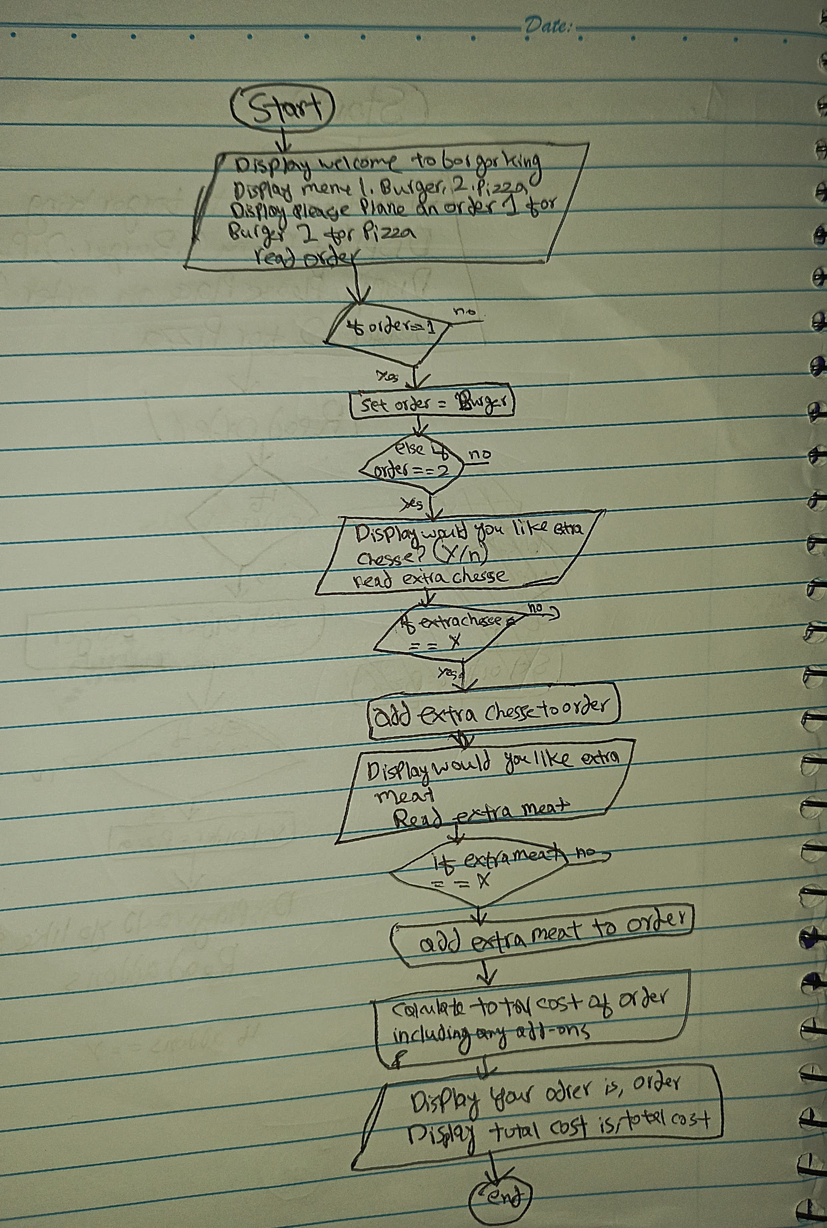

2. Design a flowchart, Pseudocode, Algorithm for handling a customer's deposit transaction at a bank, including checks for account validity and deposit amount conditions

**Pseudocode**

Start

Display welcome to ATM

Display enter your account number

If account number == 12345678

Then display enter password

Else display incorrect account number

Then repeat step 5

Display enter password

If password ==98765

Then display enter an amount

Else display wrong password

Repeat step 10

Read amount

If amount <=100000

Deposit cash

Else display insufficient balance

Then repeat step 12

END

**Algorithm**

1. Start
2. Display welcome to atm
3. Display enter your account number
4. Read account number
5. If account number == 12345678
6. Display enter password
7. Else display wrong account number and Display enter account number again
8. Read password
9. If password == 98765
10. Display enter amount
11. Else display wrong password and Display enter password again
12. If amount <==100000
13. Deposit the cash
14. Else display insufficient balance enter amount again
15. End

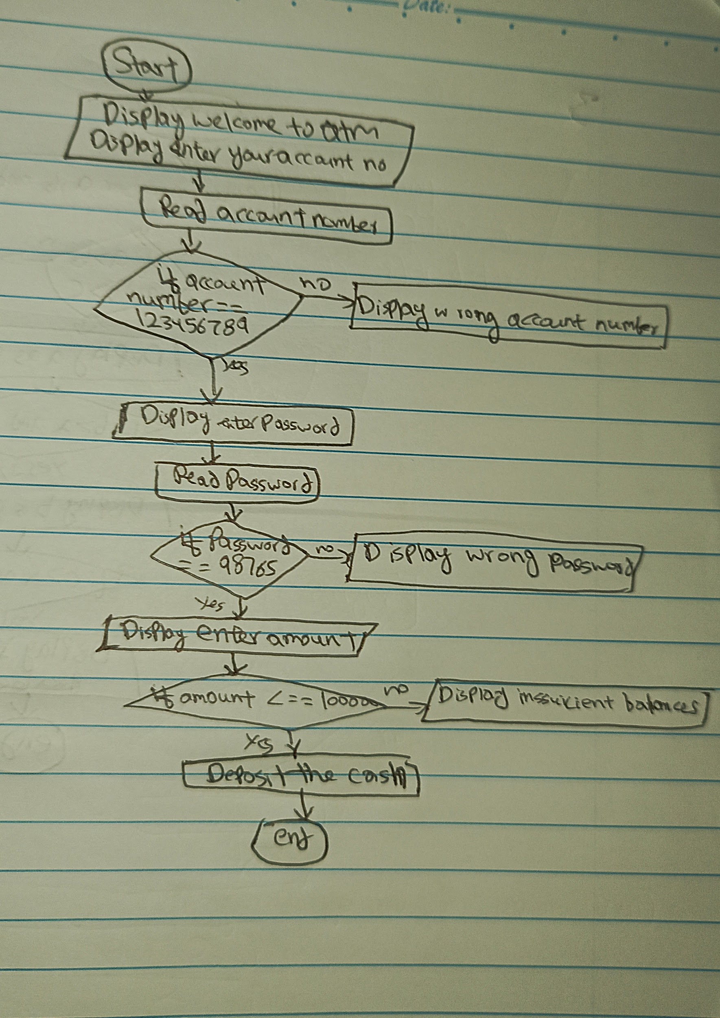

3. Design a flowchart, Pseudocode, Algorithm to determine which of three provided numbers is the greatest.

**pseudocode**

Start

Enter number a

Enter number b

Enter number c

If a>b and a>c

Then display a is the greatest number

Else if b>a and b>c

Then display b is the greatest number

Else if c>a and c>b

Then display c is the greatest number

End

**Algorithm**

1. Start
2. Enter number a ,b and c
3. If a>b and a>c
4. Display a as greatest
5. If b>a and b>c
6. Display b as greatest
7. If c>a and c>b
8. Display c as greatest
9. End

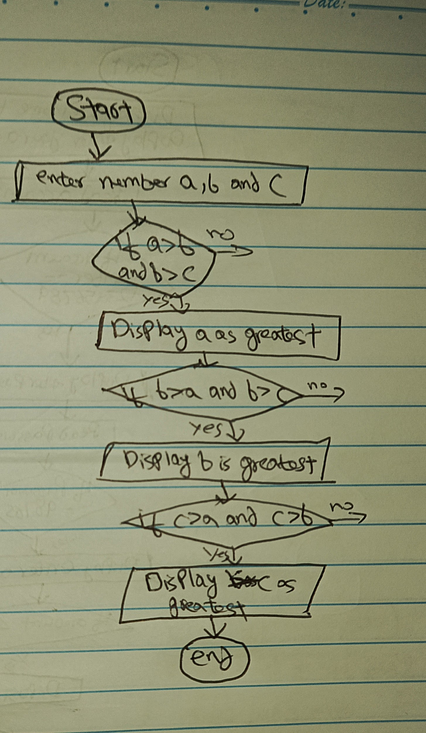

4. Implement an algorithm where the user enters a number, and an appropriate month is displayed.

Start

Enter number

If number is 1 then display January

If number is 2 then display February

If number is 3 then display march

If number is 4 then display April

If number is 5 then display may

If number is 6 then display June

If number is 7 then display July

If number is 8 then display august

If number is 9 then display September

If number is 10 then display October

If number is 11 then display November

If number is 12 then display December

5. Create pseudocode a small calculator which only does ‘+’ or ‘-‘Operations. (Hint: Take three variable inputs with one being used for the operator

Start

Declare number1, number 2 , operator, result

Print Enter first number

Input num1

Print Enter operator

Input operator

Print "Enter second number:"

Input num2

If operator == +

Result= num1 + num2

Display result

Else If operator == -

Result = num1 - num2

Display result

End

Q.6

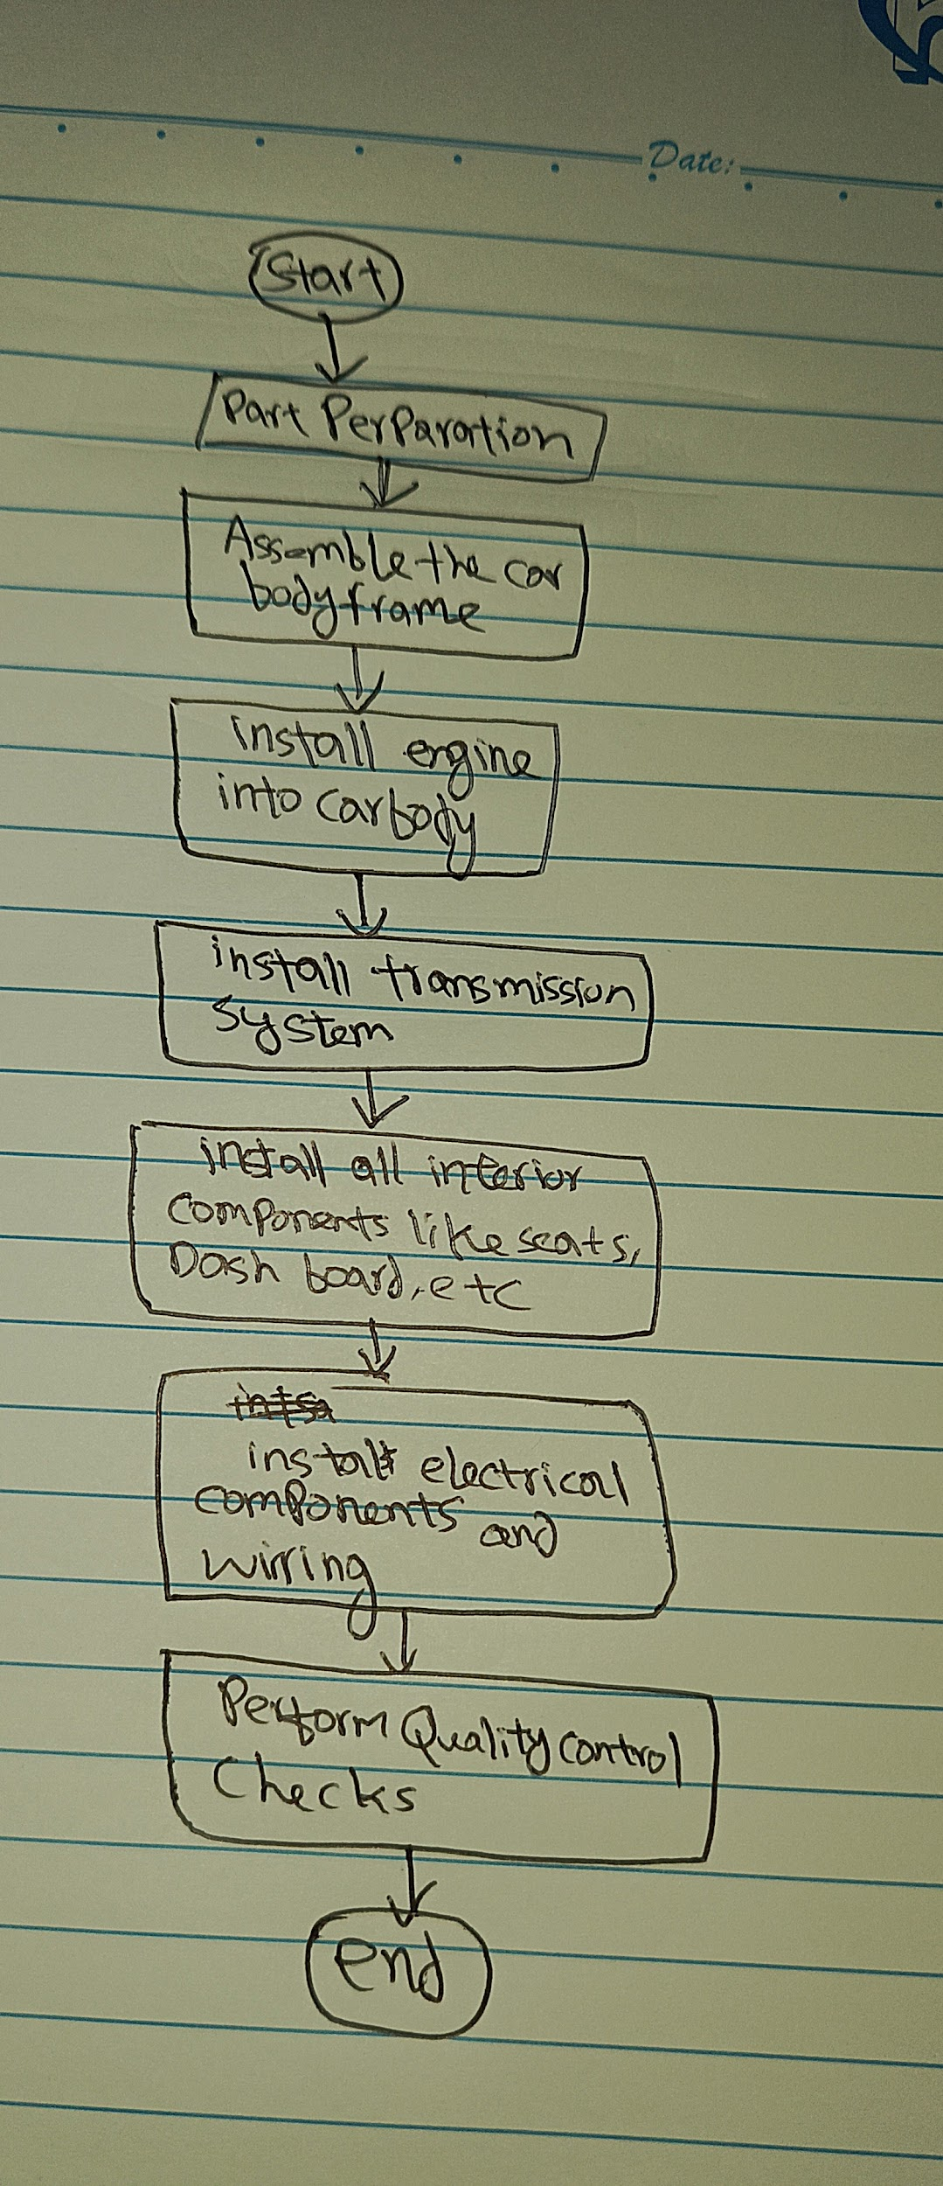

7. Implement an algorithm for making a simple calculator with all the operators (+,-,*,/,%)

Start

Declare variables num1,num2, operator , result

Input num1

Input operator (+,-,*,/,%)

Input num 2

If operator is +,

Then Set result to num1 + num2.

Else If operator is -

Then Set result to num1 - num2.

Else If operator is *

ThenSet result to num1 * num2.

Else If operator is /,

Then If num2 is not 0

Then Set result to num1 / num2

ElsePrint Error Division by zero is not allowed

Else If operator is %

ThenIf num2 is not 0

Then Set result to num1 % num2

Else display Error Division by zero is not allowed

Display result

End

9. Why we use gitignore

1. To protect information that should no be shared
2. To exclude unnecessary files which are generated by operating system , development processes or build processes and don't need to be tracked
3. To reduce repository size by ignoring files that are not necessary for sourcecode

10 Differences b/w algorithm and pseudocode

Algorithm

A set of instructions to solve a specific problem. Think of it as recipe that tell you hoe to do something and in what order to do that thing

Pseudocode

It is just a way of writing algorithm in own language , instead of actual programming language it is supposed to be easy to read and understand even if you don't know a specific programming language